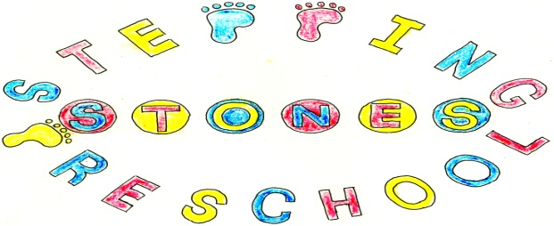

**Stepping StonesPreschool**

**Policy for epidemics and pandemics**

Stepping Stones Pre School is committed to following Government guidelines on the control of infections and viruses. Regular assessment of any information that is published by the Government will be followed. This will checked on a regular basis to ensure up to date information.

Families who travel to an identified area of risk will be asked to follow Government guidelines for the country or area visited, follow any recommendations from Government and make this known to the setting.

Guidelines may mean ensuring that children and staff with colds, including coughs and the need to use an asthma inhaler are not allowed to attend the setting. We also have to ask that parents who have cold stay outside the setting. We ask that parent respect our current arrangements for children and keep them off when they are unwell. Children will have their hands washed following Government guidelines.

Staff members may also become ill or have children who may become ill and will need to care for them increasing staff absence. We have a statutory ratio of children to staff in the setting and enforced absence of staff may mean that we do not have the correct number of staff to open. This will mean that we will be forced to close. We will give parents as much notice as we can in this situation.

Government may force schools and early year’s establishments to close to limit the spread of any diseases or viruses and Stepping Stones will give parents as much notice as possible but this is likely to happen with short notice. If the setting is forced to close because of Government ruling or the setting closes because of the lack of staff then fees will no longer be payable.

Stepping Stones is dedicated to keeping children safe and a deep cleanse of the setting will be done when this is needed to control infections. This will enhance our current cleaning regime for all areas and contact points and hand washing regime.

**THIS POLICY WAS ADOPTED AT A MEETING OF**

**THE PRESCHOOL HELD ON (DATE) ....................................................**

**SIGNED ON BEHALF OF THE PRESCHOOL..........................................**